Combine Files into a Single PDF and Arrange Pages into a Logical Order
Best practice: Set a state order (Index) of pages so ICJOs & Field Officer know the expected order of
documents for operational efficiency

-1- Open Adobe Acrobat: Select: “File” > “Create” > “Combine Files into a Single PDF”
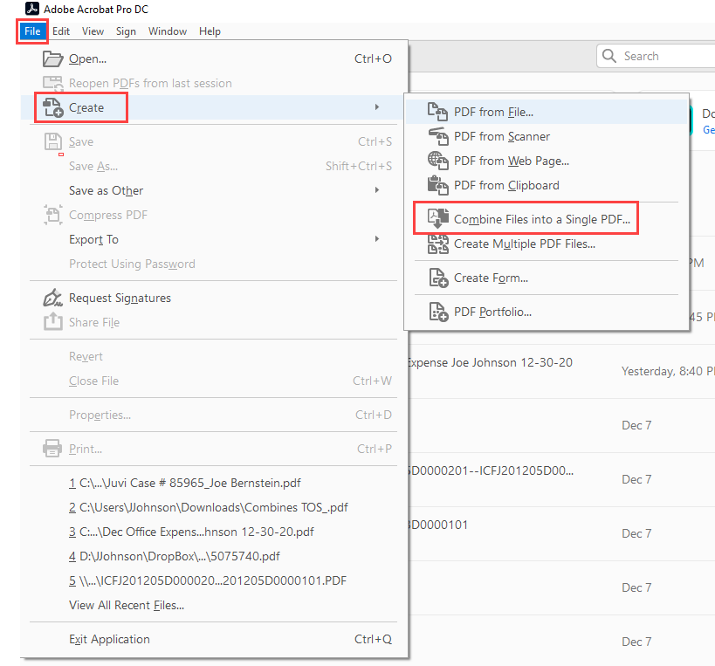

-2- Select: “Add Files” & Select File(s) that you want to combine into the PDF
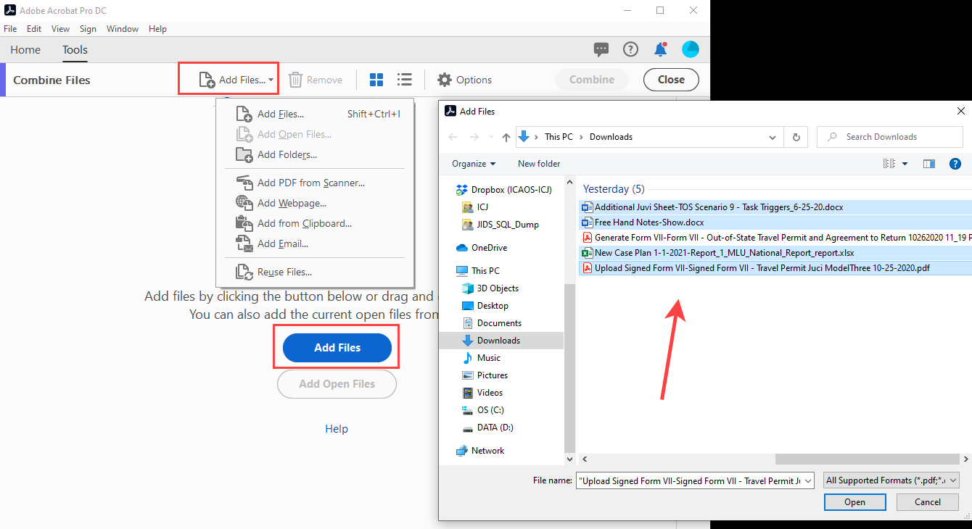
-3- Arrange the files into the best and most logical order for review & Select “Combine”
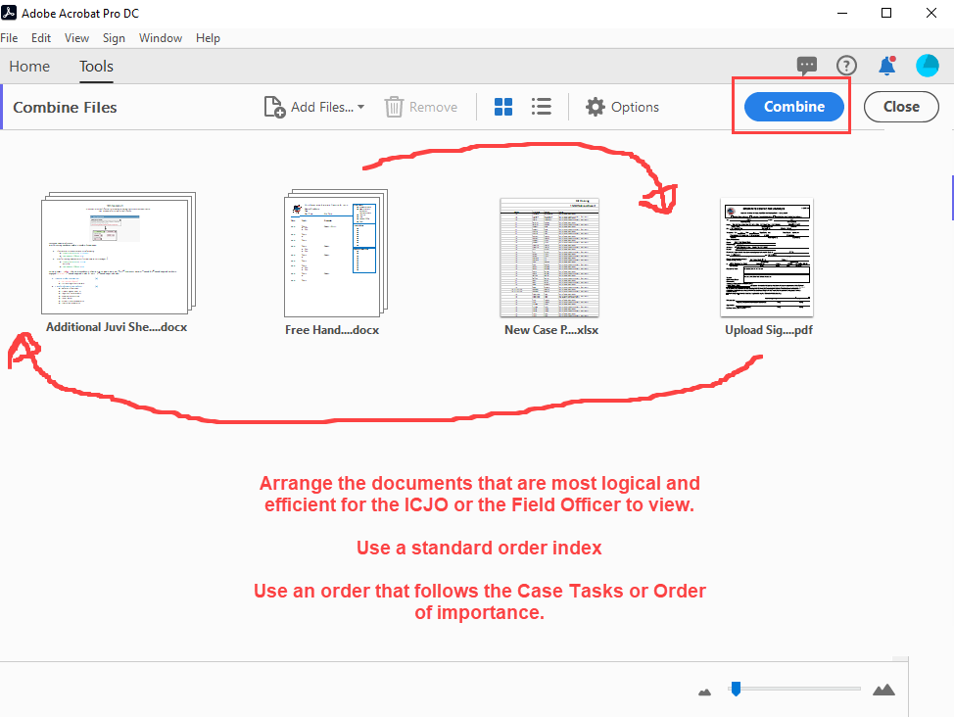
-4- Once combined into a single document, review the pages, make any page order changes.
Once done: Select “File” > “Save As” and Name and Save the document to your specified location.

